Elastic SIEM Implementation Using Docker for Centralized Log Monitoring

Introduction
Today’s systems generate a huge amount of logs, and monitoring them manually is difficult.
This project focuses on building a complete SIEM (Security Information and Event Management) environment using the Elastic Stack. The goal is to collect logs from multiple systems, centralize them in one place, visualize them through dashboards, and detect suspicious activity through alerts.
In this project, I deployed Elasticsearch and Kibana using Docker to make the setup fast and portable. I installed log collection agents (Filebeat/Winlogbeat) on different systems to forward system logs into the SIEM. Using Kibana, I created dashboards to monitor system activity and configured alerts to identify potential security issues such as failed login attempts or unusual user behavior.
This project demonstrates practical skills in security monitoring, log management, Docker configuration, dashboard creation, and detection engineering. It also helps understand how SIEMs work in real-world environments.

Tools and Technologies Used
This project uses several tools that work together to create a complete SIEM setup.
Below is a simple explanation of each tool and why it is used.

2.1 Docker
Docker is used to run Elasticsearch and Kibana in containers.
It makes the setup easy, fast, and consistent because everything runs in isolated environments.

2.2 Elasticsearch
Elasticsearch is the main database of the Elastic Stack.
All logs collected from the systems are stored here.
It allows fast searching, indexing, and analysis of log data.

2.3 Kibana
Kibana is the web-based interface used for visualization.
It provides dashboards, charts, SIEM tools, rule creation, and alert management.

2.4 Filebeat / Winlogbeat
These Beats are lightweight agents installed on each machine.
- Filebeat collects logs from Linux or macOS
- Winlogbeat collects Windows Event Logs
They send these logs to Elasticsearch for analysis.

2.5 Elastic Agent (Optional)
Elastic Agent is an all-in-one agent used for logs, metrics, and security monitoring.
It can be used instead of Filebeat or Winlogbeat and is managed through Elastic Fleet.

2.6 Docker Compose (Optional)
Docker Compose helps run multiple containers (Elasticsearch + Kibana) together using one command.

Project Architecture
The architecture of this project shows how all components work together to create a centralized SIEM environment.
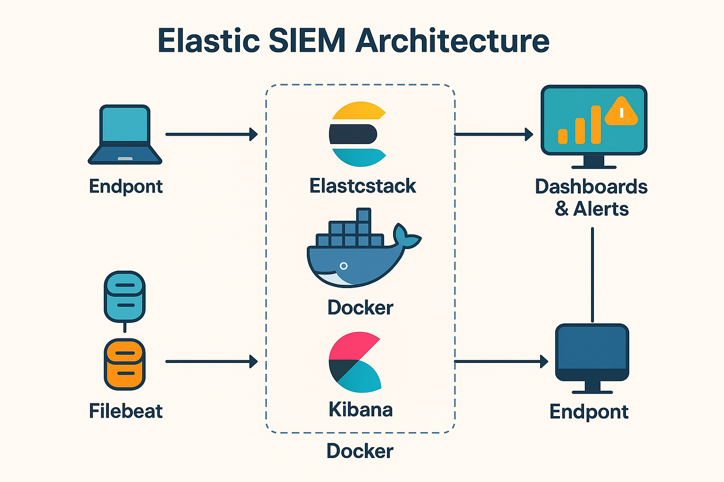

3.1 Elastic Stack (Core SIEM Platform)
The Elastic Stack (Elasticsearch + Kibana) runs inside Docker containers.
- Elasticsearch stores all incoming logs.
- Kibana provides the interface to view, analyze, and visualize the logs.
Running these in Docker makes the deployment easy and portable.

3.2 Log Collection Agents
Each system that needs to be monitored has an agent installed:
- Filebeat (Linux/Mac)
- Winlogbeat (Windows)
- Elastic Agent (Optional for unified monitoring)
These agents collect system logs such as:
- Authentication logs
- System events
- Application logs
- Error and warning logs
They send these logs to Elasticsearch continuously.

3.3 Data Flow
The flow of data in this project works like this:
- Endpoints generate logs
(example: login events, process execution, system warnings)
- Beats/Agents collect logs
They read log files or event logs in real-time.
- Logs are forwarded to Elasticsearch
Elasticsearch indexes the logs for searching and querying.
- Kibana visualizes the data
You can view the logs, build dashboards, and detect threats.

3.4 Dashboards & Alerts Layer
Inside Kibana SIEM:
- Dashboards show system trends, login activity, host performance, etc.
- Alerts notify about suspicious events like:
  - Multiple failed login attempts
  - New user account creation
  - Unusual administrative actions
This forms the detection mechanism of your SIEM.

3.5 Multi-Host Monitoring
The project includes more than one system sending logs.
This creates a realistic scenario similar to real SOC (Security Operations Center) environments.

Setup & Implementation Steps
Install Docker Desktop (Windows)
Step 1 — Download Docker Desktop
Go to:
https://www.docker.com/products/docker-desktop/
Step 2 — Install
- Double-click installer
- Enable WSL 2 during installation
- Restart PC after installation
Step 3 — Verify Docker
Open PowerShell:
- docker --version
- docker compose version

Run Elasticsearch + Kibana Using Docker Compose (Windows)
Step 1 — Create a project folder
mkdir elastic-siem
cd elastic-siem
Step 2 — Create docker-compose.yml
Create a file named docker-compose.yml with this content:
Content :-
version: "3.8"

services:
elasticsearch:
image: docker.elastic.co/elasticsearch/elasticsearch:8.13.0
container_name: elasticsearch
environment:
- discovery.type=single-node
- ES_JAVA_OPTS=-Xms1g -Xmx1g
ports:
- "9200:9200"
volumes:
- esdata:/usr/share/elasticsearch/data

kibana:
image: docker.elastic.co/kibana/kibana:8.13.0
container_name: kibana
depends_on:
- elasticsearch
ports:
- "5601:5601"

volumes:
esdata:

Step 3 — Start the Elastic Stack
docker compose up -d
Step 4 — Verify containers
docker ps
Step 5 — Open Kibana
In browser:
http://localhost:5601

How to get the Enrollment Token (Windows–Docker)
✔ Step 1 — Open PowerShell
Run as Administrator.
✔ Step 2 — Get inside your project folder (same folder as docker-compose.yml)
cd elastic-siem
✔ Step 3 — Run this command:
docker exec -it elasticsearch bin/elasticsearch-create-enrollment-token -s kibana
💡 What this command does:
- docker exec → run command inside the Elasticsearch container
- -it → interactive terminal
- elasticsearch → container name
- elasticsearch-create-enrollment-token → generates a token
- -s kibana → token for Kibana setup
✔ Step 4 — Copy the token shown
The token will look like:
eyJ2ZXIiOiI4LjEzLjAiLCJ...
(It will be very long.)
✔ Step 5 — Paste the token in the Kibana page
Paste it here:
✅ Step 1 — Open PowerShell (Run as Administrator)

✅ Step 2 — Run this command to get inside Kibana container
docker exec -it kibana /bin/bash
💡 Meaning:
- docker exec = run inside the container
- -it = interactive mode
- kibana = container name
- /bin/bash = open shell inside container
If your container name is different, run:
docker ps
to confirm.

✅ Step 3 — Run the Kibana verification code command
Inside the container, run:
bin/kibana-verification-code
or sometimes:
bin/kibana-verification-code.bat
💡 This will show something like:
Your Kibana verification code is: 123456
This 123456 is the code you need.

✅ Step 4 — Exit container
Type:
exit

✅ Step 5 — Enter the 6-digit code into your browser
Go back to Kibana screen → Enter the code → Click Verify
🎉 Now Kibana will move to login page.

⭐ After this, Kibana will ask for a login
You’ll be prompted for:
- Username:
elastic
- Password:
Your Elasticsearch auto-generated password.
If you forgot it, run:
docker logs elasticsearch | findstr "password"
On PowerShell this works:
docker logs elasticsearch | Select-String "password"
You will see something like:
The generated password for the elastic user is: Xx9TnHk3abcXYZ==
Use this password to log in.

